# Design Brief

## Overview

**Project Name:** Digital Fridge

**Project Brief Description:** To build a system that collects and stores personal notes for users

**Client Company Name:** 31Tech

**Owner:** Martin Ward

**Other Stakeholders:**

Claire Thexton

Ed Roberts

Nicole Cloughton

## About the Client/Company

31 Tech are a starter IT Consultancy that specialise in web systems.

## Project Goals and Objectives

The aim of the project is to develop an application that will allow users to store personal notes, images, and other content in one place. From the title of the project, you can see that the aim is to make a digital version of the stereotypical ‘fridge’ users may have had at home.

In addition, this project also aims to build the foundations in which the company can develop and improve their DevOps capabilities.

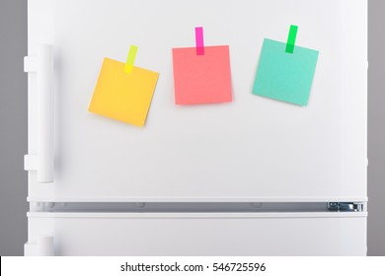 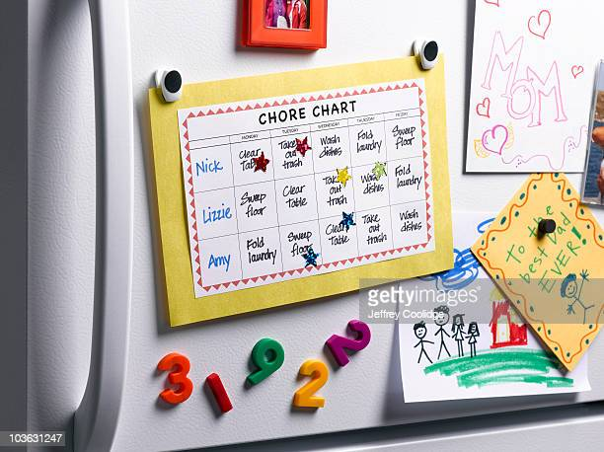 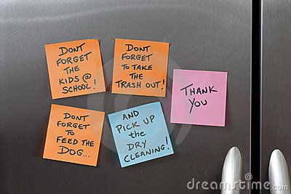

## Target Audience

It is aimed at all ages and genders. The focus of the project is to develop somewhere to store notes, reminders, images, messages, so it will be aimed at families and general workers.

## Project deliverables

A system which interacts with the three tiers of a three-tier architecture system.

This will include:

* A website
* A Server
* A Database

The above will also come with implemented DevOps operations that can be used to teach and template off for future projects. These areas will include:

* Continuous Integration
* Deployment
* Maintainability
* Scalability
* Observability
* Load Balancing
* Security

# UX design

## Logo

**Final Design**

**Sketches**

**Mood Boards**

## Website

**Final**

**Sketches**

**Mood Board**

Story Board

Personas

# Data Design

Relationship stuff

Database Stuff

# Code Design

Languages, methods, functions etc

# Protocol Design

Client/server?

Peer to peer?  
Standards?  
Encrypted?  
Human readable?